3x3 Observations: December 2009
SCIENCE Department – 9 Classes

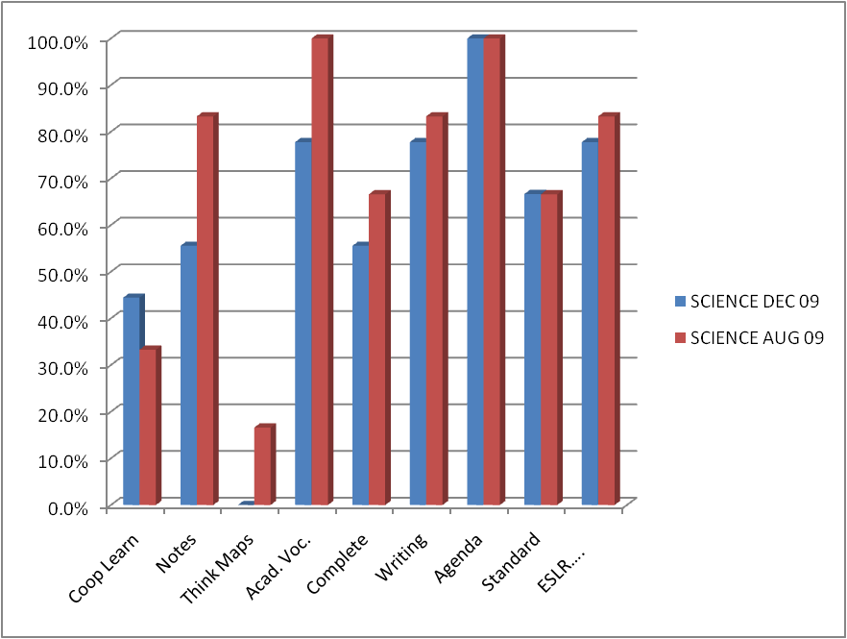

SCIENCE | Coop Learn | Notes | Think Maps | Acad. Voc. | Complete Sentences | Writing | Agenda | Standard | ESLR….
Dec 09 | 44% | 56% | 0% | 78% | 56% | 78% | 100% | 67% | 78%
Aug 09 | 33% | 83% | 17% | 100% | 67% | 83% | 100% | 67% | 83%

